1. Plug in power and audio out on your Hyve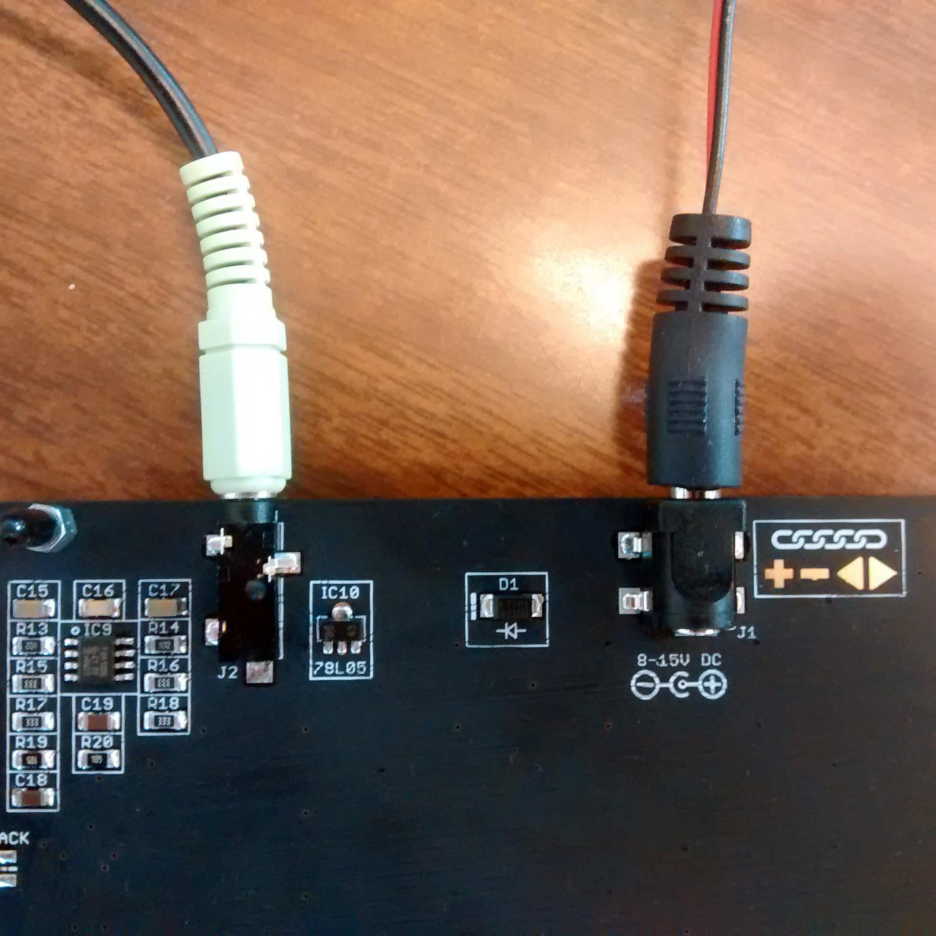
2. Play a reference tone in this folder
3. Touch the hexagonal tuning point on the upper right of the back of your Hyve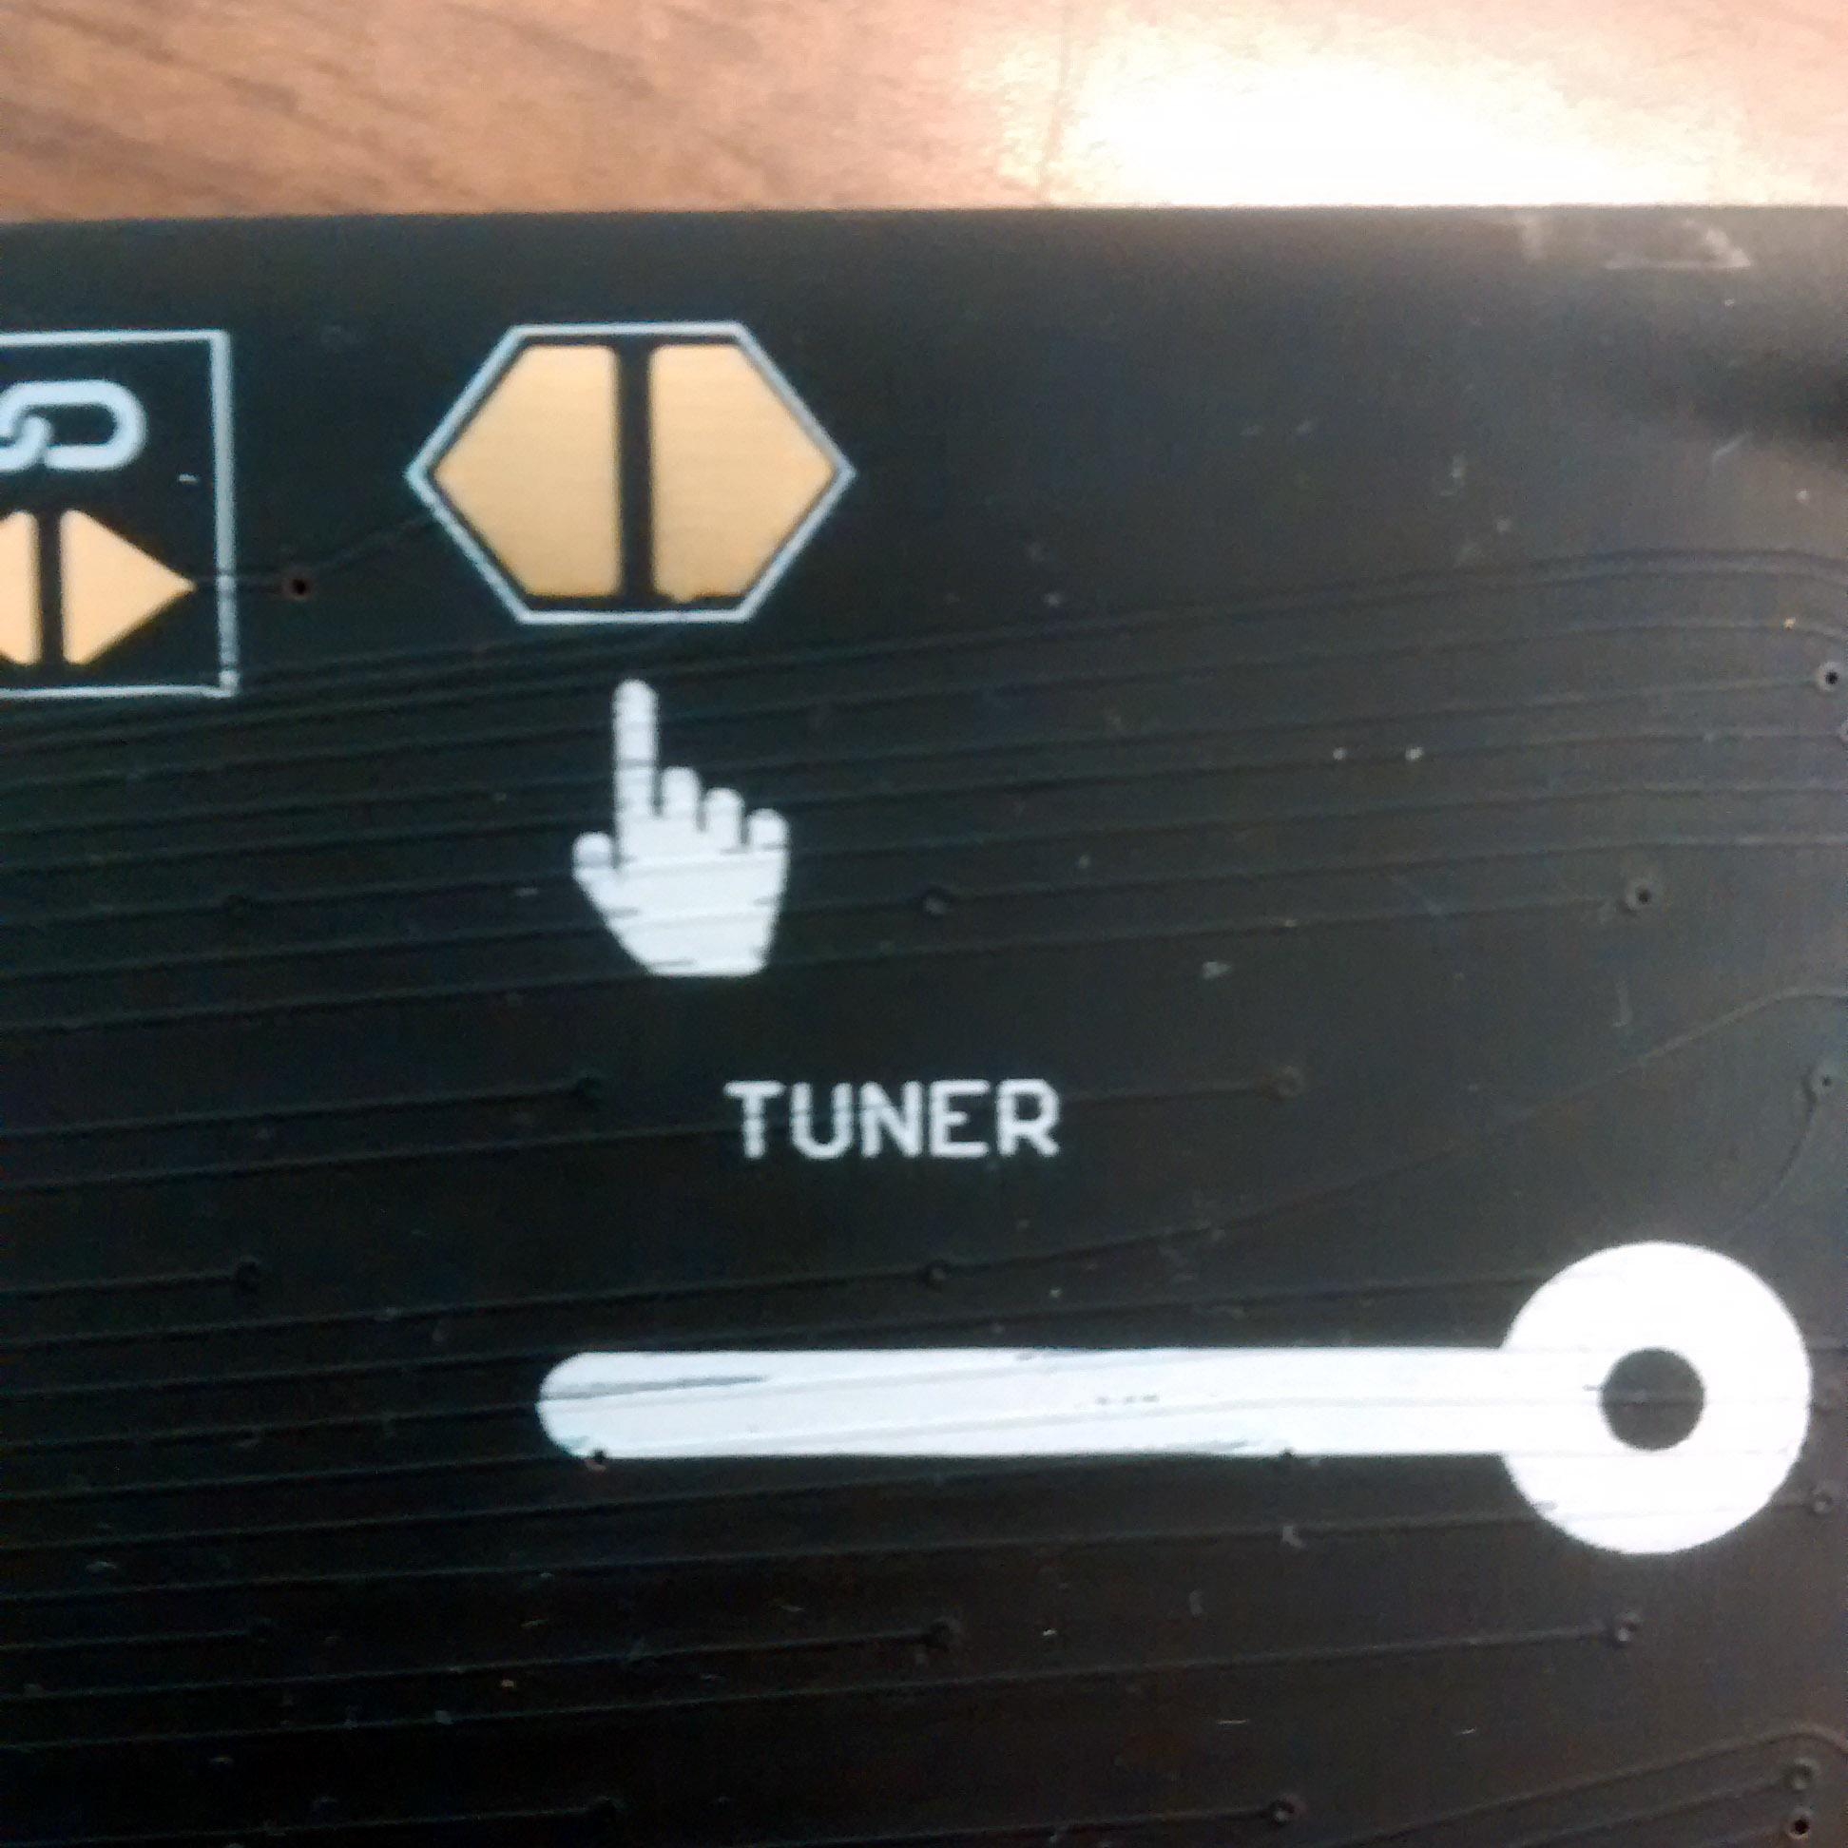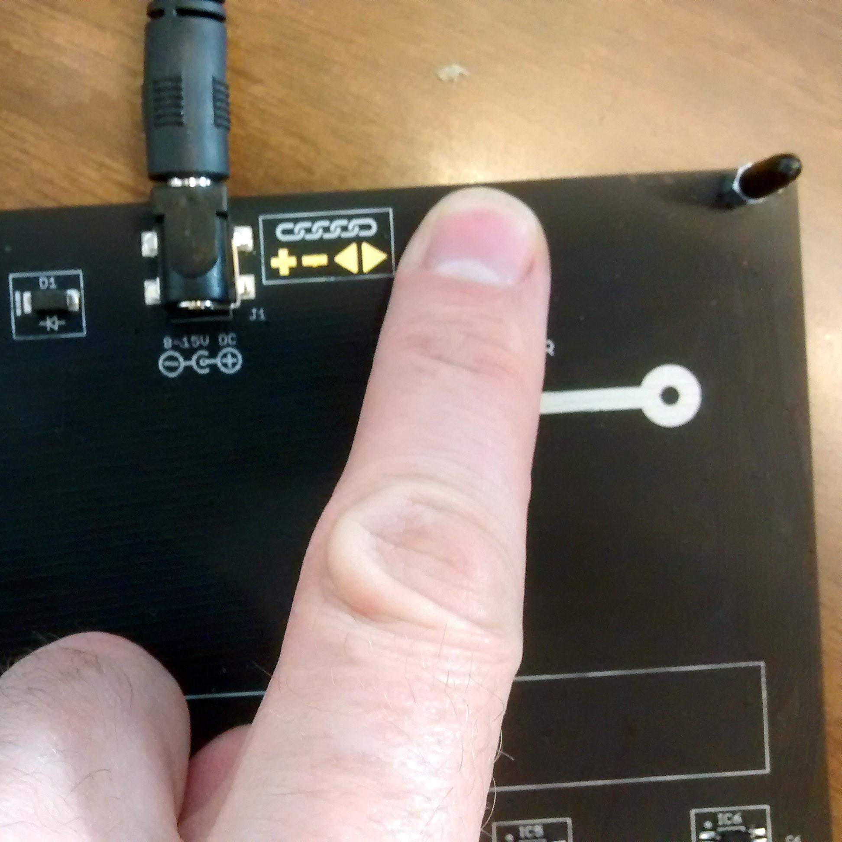
4. Use the tuning tool to gently turn the tuning screw associated with the note of the reference tone you are playing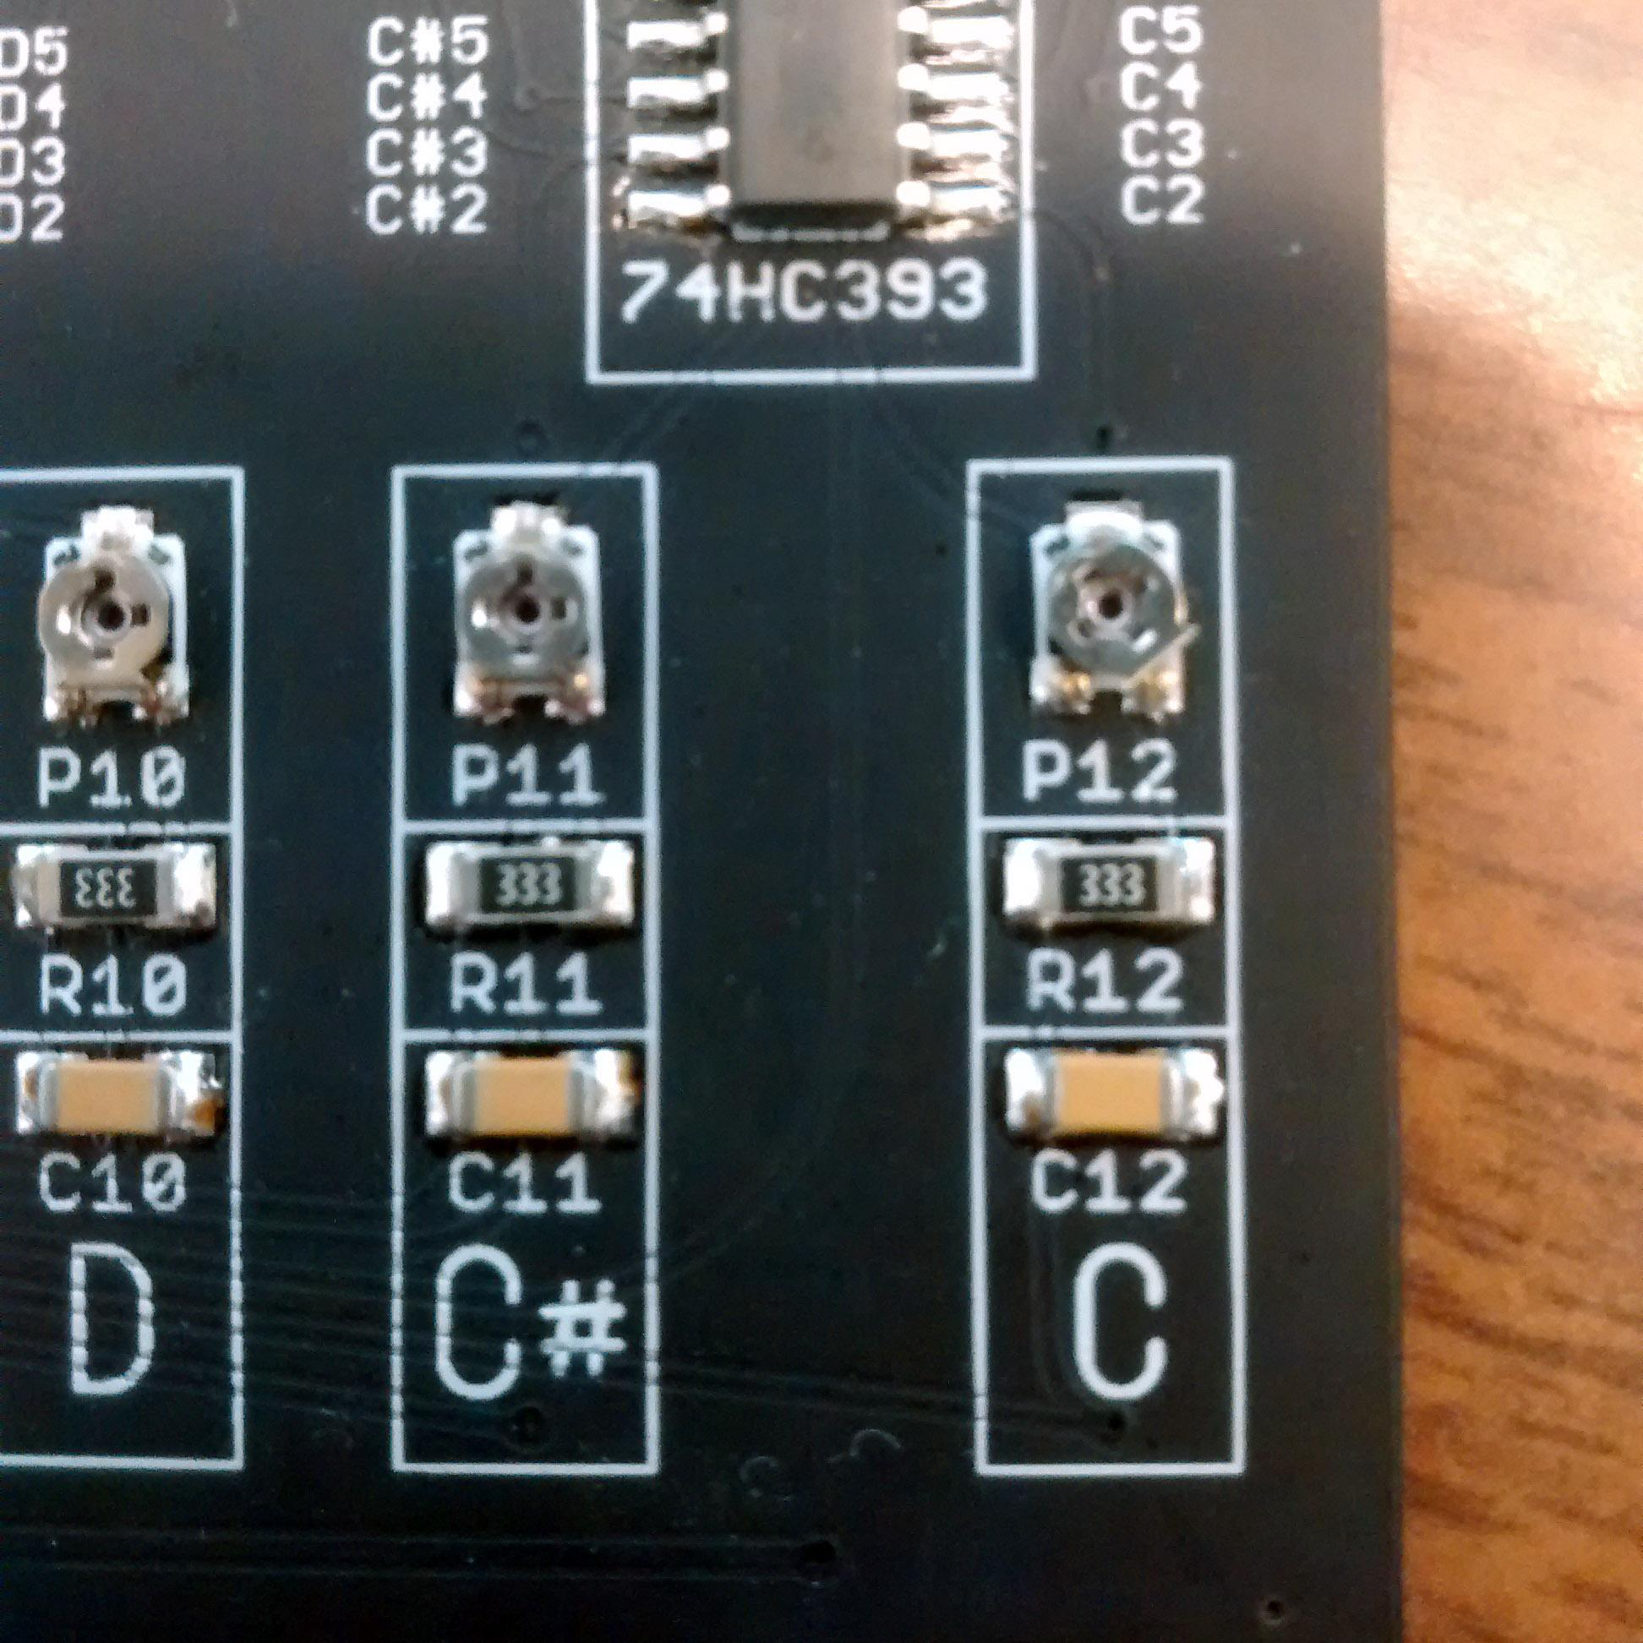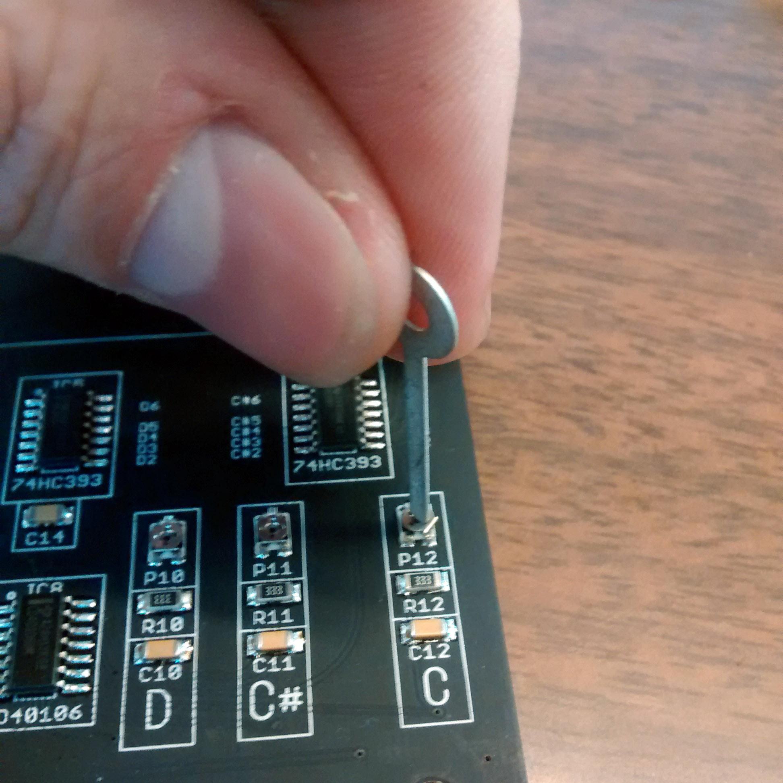
5. Repeat for all notes until they match each reference tone